Name:________________________ Date:___________
Mr. Kaufman Geometry

Reflections

1. Find the image of triangle ABC after a reflection over the line y = x. Then prove that the image is congruent to the preimage.
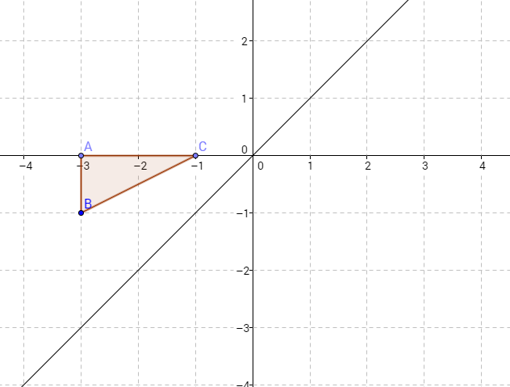

Proof:

2. You are designing a college campus. Rectangle ABCD represents one building that you have planned. It might be cool to have two buildings on the campus mirror each other so you decide to reflect your building over the line y = 1. Your partner claims that your new building won't be the same as the first one.

Make a claim that either agrees or disagrees with your partner. Then support your claim with evidence.

CLAIM: ____________________________________________

Evidence 1:

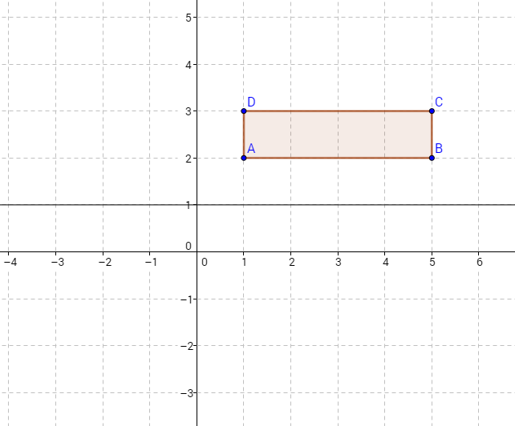

Evidence 2: Prove that rectangle ABCD and its image are congruent.

