Name:________________________ Date:___________
Mr. Kaufman Geometry

Equation of a Circle

Example 1: Write the equation of a circle with center at (3,-5) and a radius of 3.

Example 2: Given the equation of a circle, , what are the coordinates of the center and the radius?

Example 3: What is the equation of this graph?
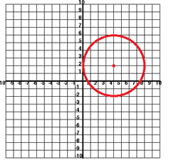

Independent Practice:
1. What is the equation of a circle whose diameter is 24 and whose center is at the origin?

2. The point (1,2) is on the circle whose equation is
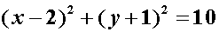

True or False?

Support your answer with a diagram.
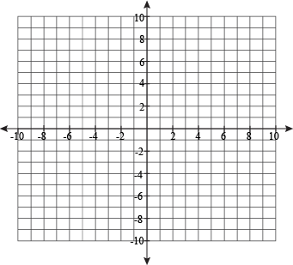

3. An ambulance company provides services within an 80 mile radius of their headquarters. If this service area is represented graphically, with the headquarters located at the coordinates (0,0), what is the equation that represents the service area?

