Name:________________________ Date:___________
Mr. Kaufman Geometry

Linear-Circular Systems

1. Solve the system by graphing.
$x^{2}+y^{2}=25$
$x + y=5$

Checklist:
- Graph the circle by hand.
- Graph the equation by hand or using a calculator.
- Look for the point/s of intersection.
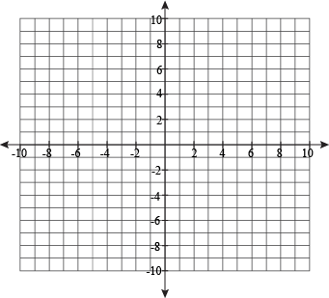

2. Solve the system by graphing.
$x^{2}+y^{2}=16$
$y=-4$

Checklist:
- Graph the circle by hand.
- Graph the equation by hand or using a calculator.
- Look for the point/s of intersection.

3. The city government wants to build a street to connect Union Ave. and Banker St. They feel that this will reduce traffic in the Williamsburg and Greenpoint neighborhoods. When placed on a coordinate plane the road follows the path of the equation $y=1$. One of the circular paths at McCarren Park can be modelled using the equation $x^{2}+(y^{2}-1)=4$.

CLAIM: The city government (circle one choice) should / should not build the connecting street.

Evidence 1:
Evidence 2: The graph above shows ________________________________________
________________________________________________________________________________________________________________________________________________________________________________________________________________________________________________________________________________________________________________________________________________________.

