CHEMISTRY | CODE: SCS22B
2014-2015 SCHOOL YEAR | INSTRUCTOR: Ms. Bui
CLASSROOM: 510 | LAB ROOM: 506
CHEMICAL BOND
ENERGY
Name_______________________________________ | Period: _____________________________________
Date: ______________________________________ | Subject: Chemistry

SCIENCE STARTER:
Instructions: Choose the best answer
1. You want to make a cup of hot tea. What happens to the energy when the water is heated?

2. Your friend wants a cup of iced tea. What happens to the energy when ice is added to a cup of hot tea?

Instructions: Do the simulation related to each picture. Complete the table below the following energy systems.
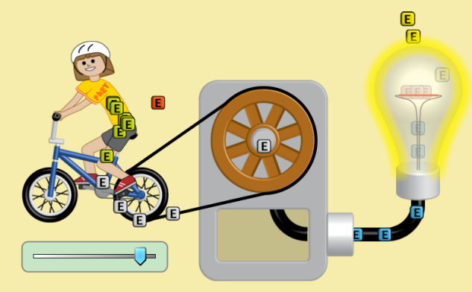
energy form | original | transformed into/ transferred to | result
 | from the girl’s digestion | transformed into mechanical energy | moves her legs
 | from the legs | transferred to mechanical energy | moves the wheels
 | from the wheels | transformed to electrical energy | heats the wire inside the bulb
 | from the wire | transformed to light energy | radiates out into the room.

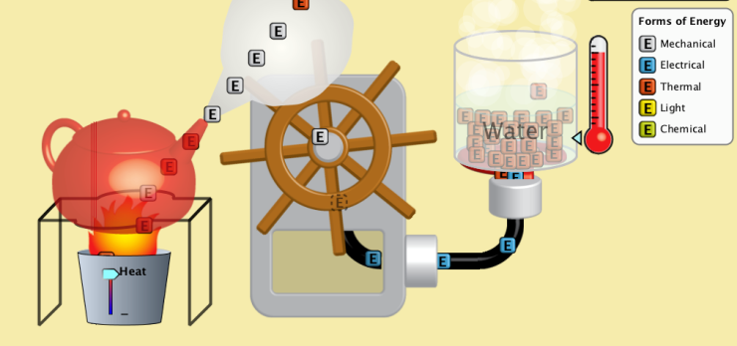

energy form | original | transformed into/ transferred to | result
 | from the burner | transferred into thermal energy | heats the water to steam
 | from the steam | transformed to mechanical energy | moves the wheel
 | from the wheel | transformed to electrical energy | heats the wire inside the bulb
 | from the wire | transferred to electrical energy | heats the burner
 | from the burner | transferred into thermal energy | heat the water

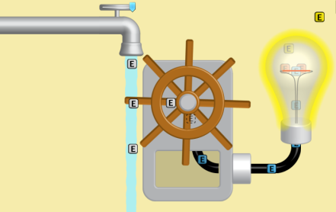
energy form | original | transformed into/ transferred to | result

Extension
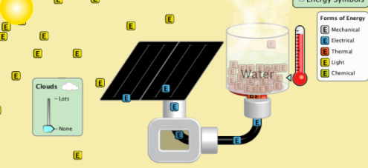
energy form | original | transformed into/transformed to | result

AIM Prompt: Of the energy systems in the simulation, what is the best energy system to melt ice for washing? Use RACE (a paragraph of at least 3 sentences). State your claim and provide evidence.
____________________________________________________________________________________________________________________________________________________________________________________________________________________________________________________________________________________________________________________________________________
____________________________________________________________________________________________________________________________________________________________________________________________________________________________________________________________________________________________________________________________________________
______________________________________________________________________________________________________________________________________________________________________

