Name:________________________ Date:___________
Mr. Kaufman Geometry

Dilation Homework

1.
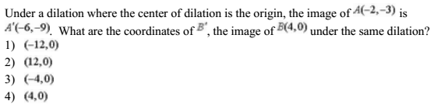

2.
