Name:________________________ Date:___________
Mr. Kaufman Geometry

Rotations

Guided Practice:
1. Draw the image of the letter P after a clockwise rotation of 180 degrees.

2.

3.

4. Draw and label the image of this triangle after a 270 degree clockwise rotation.
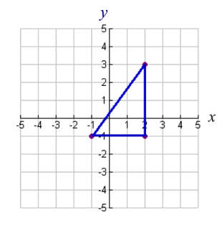

Independent Practice:

You’re going to make a unique piece of art!

- On the graph below, draw a figure entirely inside of the 1st quadrant with one corner of the figure on the origin.
- Label the coordinates of your figure.
- Then rotate the figure 3 times. Rotate it clockwise 90 degrees, 180 degrees, and 270 degrees. Each time you rotate it label the coordinates of the image.

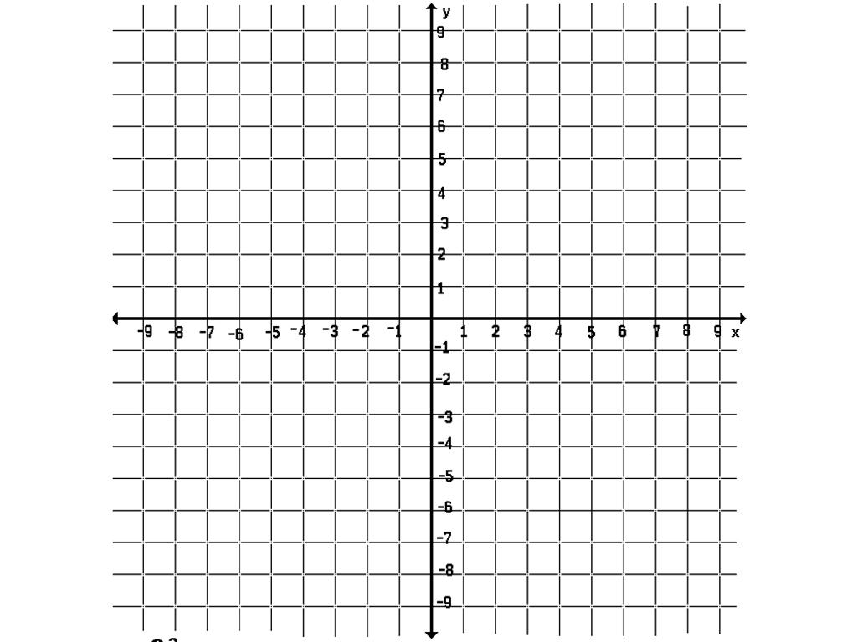

CLAIM: My figure and each of its images are ____________.

Evidence #1: Your graph!

Evidence #2: How do you know that your claim is true? _______________________________________________________________________________________________________________________________________________________________________________________________________________________________________________________________

