Name:________________________________________
Strictly Stage Directions CCSS Writing Project
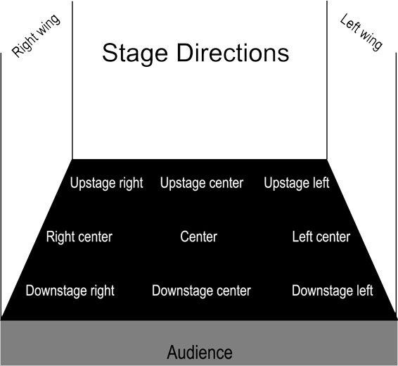
Choose 1 of the following scenes from A Raisin in the Sun, The Crucible, or Macbeth and create a Strictly Stage Direction Version of the Scene that should create a specific Mood in the Audience without directly stating the Mood you are trying to create. Use as many details as possible, some scenes will be performed at the Night at the Amory, which is June 8th.
You may choose 1 of the following Moods and Scenes:
- Create a Hyper/Jubilant Mood in the Audience:
  - A Raisin in the Sun by Lorraine Hansberry – Act III (Pages 148-151)
  - The Crucible by Arthur Miller –Act I (Pages 50-54)
  - Macbeth by William Shakespeare – Act I, Scene VII (Pages 39-45)
OR
- Create an Aggravated/Irate Mood in the Audience:
  - A Raisin in the Sun by Lorraine Hansberry – Act II (Pages 127-130)
  - The Crucible by Arthur Miller –Act III (Pages 120-122)
  - Macbeth by William Shakespeare – Act II, Scene III (Pages 65-73)
OR
- Create an Anxious Mood in the Audience:
  - A Raisin in the Sun by Lorraine Hansberry – Act I (Pages 70-71)
  - The Crucible by Arthur Miller –Act IV (Pages 142-146)
  - Macbeth by William Shakespeare – Act II, Scene II (Pages 55-61)

