Nombre:__________________________ Clase:_____ Fecha:________________________
REVIEW FOR MIDTERM ON TUESDAY MARCH 17th!
Part 1: You must know these terms. They will be in a matching exercise.
1. el plato - ________________________
2. rico - ________________________
3. el azúcar - ________________________
4. la cuchara - ________________________
5. el tenedor - ________________________
6. la pimienta - ________________________
7. el postre - ________________________
8. la sal - ________________________
9. la servilleta - ________________________
10. la taza - ________________________
11. el cuchillo - ________________________
12. el vaso - ________________________
13. el mesero - ________________________
14. la cuenta - ________________________
15. ahora - ________________________
Part 2: You must know the following also…
1. Tengo hambre! - ___________________________________________________________
2. ¿Qué recomienda usted? - ___________________________________________________________
3. Estamos listos para ordenar - ___________________________________________________________
4. ¿Qué le gustaría comer? - ________________________________________________________
5. Yo quiero…- ___________________________________________________________
6. Está picante! - ___________________________________________________________
7. ¿Algo más? - ___________________________________________________________
8. La cuenta por favor - ___________________________________________________________
9. ¿Qué le gustaría beber? - _________________________________________________________ 10. Me gustaría - ___________________________________________________________

Part 4: The Verb TENER – Know how to conjugate it!!
Part 3 is a little restaurant dialogue with reading comprehension questions.
Yo – Nosotros -
Tú –
Él/ella/Ud. - Ellos/ellas/uds. –
1. Miguel y yo _____________________ hambre!
2. Susana _____________________ un carro bonito.
3. Tú _____________________ mucho dinero
4. Nosotros no_____________________ lápices.
5. Yo _____________________ calor.
Part 5: Writing sentences about a who is related to who in family.
REMEMBER THE FORMULA = _______________ es _______________ de _______________
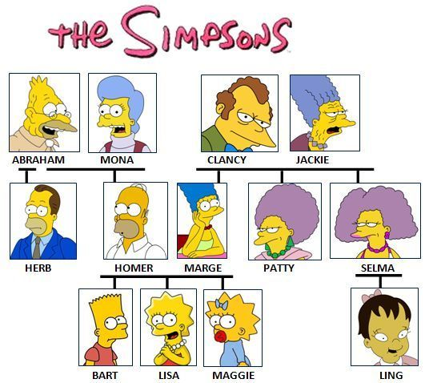
(name) (relationship) (name)

1. ___________________________________________
2. ___________________________________________
3. ___________________________________________
4. ___________________________________________
5. ___________________________________________

Part 6: African Influence on Latin-America short response.
Recall the articles and videos we studied in class. In a paragraph explain how African culture has influenced Latin-America. Give at least 2 specific examples. (10 points)
__________________________________________________________________________________________________________________________________________________________________________________________________________________________________________________________________________________________________________________________________________________________________________________________________________________________________________________________________________________________________________ __________________________________________________________________________________________________________________________________________________________________________________________________________________________________________________________________________________________________________________________________________________________________________________________________________________________________________________________________________________________________________

