Unit 1- Earth Systems and Resources AP Environmental Science
AIM: What are tectonic plates and how have they moved over time? Ms. Taylor
DO NOW:
- What is the Geologic Time Scale based on?
- What 2 events characterize the Cenozoic Era (past 65 million years)?
- What 2 events characterize the Quaternary Period (past 1.8 million years)?
- What are the two types of crust, and how are they different?

- Describe the consistency of the upper portions of the mantle

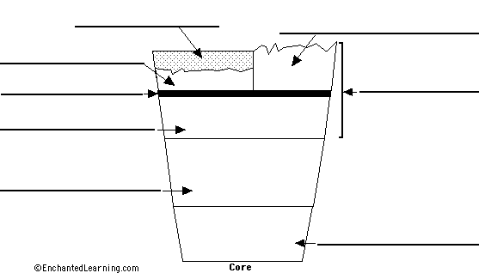
Lithosphere:
- The ___________________________ part of Earth
- Consists of the ________________, and the uppermost ___________________

Asthenosphere:
- Upper portion of the _________________
that has a “plastic-like” consistency

________________________– “plastic like”
_________________________– Solid

- Earth’s lithosphere is divided into several large pieces called “__________________________________”
- The plates are constantly moving, a phenomena known as “______________________________________”
  - 2-5 cm a year
- The plates (_________________________) are able to glide on the plastic-like portion of the mantle, known as the ____________________________
- The lithosphere glides on the ________________________________
- Slow creeping motion of the mantle is caused by ____________________________________________, carrying heat from Earth’s interior to the ____________________
- Convection currents in the asthenosphere move plates in the ________________________

The Theory of Plate Tectonics
- The theory of plate tectonics arose out of 2 separation geological observations:
The continental drift theory
The seafloor spreading theory

Continental Drift:
- Alfred Wegner proposed that all present-day continents originally form one land-mass-__________________
- Wegner proposed that this supercontinent began to break up ____________million years ago

Evidence to support his theory:
- Tropical plants fossils in _____________ climates
- Continents fit like a _____________________
- Coasts of different continents have same _________________
- ____________________of extinct species found on separated landmasses
Plate Tectonics:
- Earth’s lithosphere is divided into ____________________________________
- Divisions between plates are called ___________________________

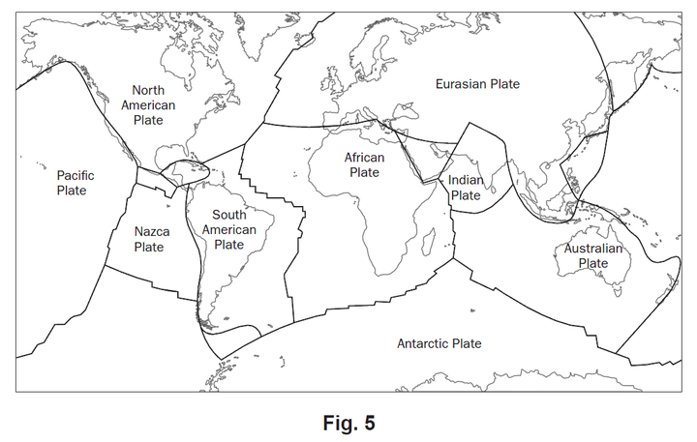

Plates interact at their boundaries:
- There are 3 types of plate boundaries
  - _______________________ boundaries
  - _______________________boundaries
  - _______________________ boundaries

Transform Boundaries:
- Two plates slide _______________each other

Divergent Boundaries:
- Two plates slide _______________ from each other

Convergent Boundaries:
- Two plates slide ___________________ each other
- If an oceanic plate and a continental plate are colliding, the oceanic plate will slide ____________________ the continental plate
The oceanic plate is more _________________
This is called _______________________________!

Name:___________________________________________________________ AP Environmental Science
HOMEWORK: Earth Systems and Resources- Plate Tectonics Ms. Taylor

- What is the lithosphere?
- What is the asthenosphere?
- What are tectonic plates?
- Which two plates meet in California?
- What allows tectonic plates to move?
- In which layer of the earth do convection currents occur?
- Describe how convection causes movement in the asthenosphere.
- What does the theory of continental drift state?
- Name 2 pieces of evidence used to support the theory of continental drift.
- Name two plates that interact in the Atlantic Ocean.
- What is the term used to describe where two tectonic plates meet?
- What is it called when two plates slide into each other?
- What is it called when two plates slide past each other?
- What is it called when two plates slide away from each other?
- Which type of boundary is involved with subduction?
- In what case would subduction occur and why?

Vocabulary: Lithosphere, asthenosphere, continental drift, convection currents, tectonic plates, plate tectonics, transform boundaries, convergent boundaries, divergent boundaries

