CHEMISTRY | EMAIL: bui@whsad.org
2015-2016 SCHOOL YEAR | INSTRUCTOR: Ms. Bui
CLASSROOM: 510 | LAB ROOM: 506
HWK 01-01
ATOM PUZZLE
Name_______________________________________ | Period: _____________________________________
Date: ______________________________________ | Grade Earned: ___________/100

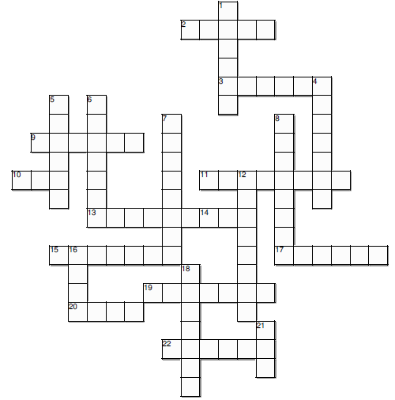
Instructions:
- Complete the crossword puzzle using the information from Unit 1 Regent Facts and pages 3-4 of the textbook.

Words Bank:
amu
proton
positive
number
nucleus
valence
u
magnitude
eleven
helium
mass
atom
equal
two
neutron
opposite
carbon
electron
chemical
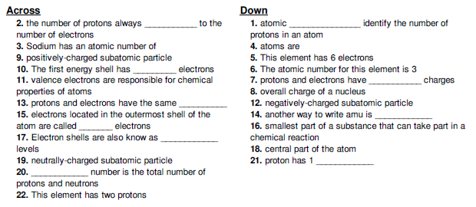
energy
neutral
lithium

