Name:_______________________________ Date: _____________
Mr. Kaufman Geometry

Unit 1: Lesson 2 (Building a Park)

Euclid’s Explanation: Normal People Explanation:
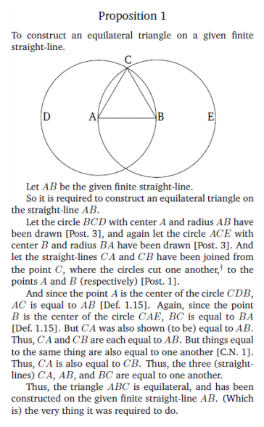

Draw 3 different sized line segments. Use each line segment to construct an equilateral triangle:

Building Parks Problem:

Points P1 and P2 below represent two parks in a town. A planning committee wants to build a third park so that it is equidistant from the other two to better serve the community. Identify two possible locations for the third park. Label them as P3a and P3b. Then write a set of steps describing how you you found the two locations.
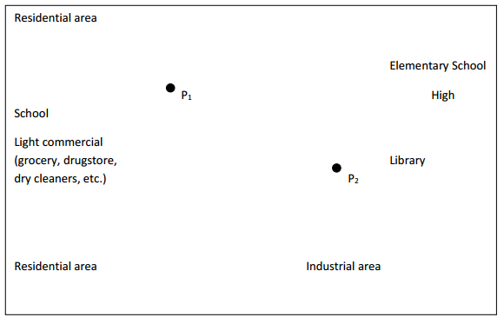
To find the possible locations for the third park, I _______________________________________
______________________________________________________________________________
____________________________________________________________________________________________________________________________________________________________

