Name:_______________________________ Date: _____________
Mr. Kaufman Geometry

Unit 1: Lesson 5 (Points of Concurrency)

AIM: ___________________________________________________________________?

Do Now: Use your compass to construct a perpendicular bisector for all three sides of the triangle below.
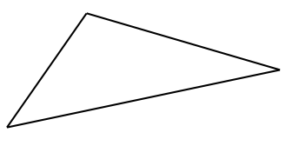

Guided Notes:
- When three are more lines intersect in a single point, they are _________________ and the point of intersection is the ___________________________.
- The point of concurrency of the three perpendicular bisectors of a triangle is called the ________________.
- The point of concurrency of the three angle bisectors of a triangle is called the _________.

Independent Practice:
Use the triangle below to construct three angle bisectors and locate the incenter.
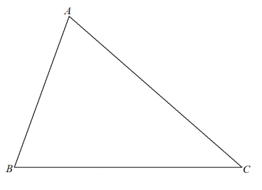
Important Idea!
- When labelling equal segments in geometry we put a dash through each segment.
- When labelling equal angles we put an arc through each angle.
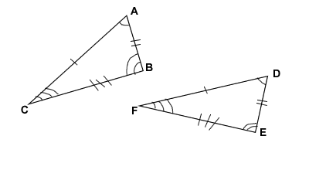

Now go back and label equal parts of the constructions on the front of the sheet.

Wrap-Up:
