Name:_______________________________ Date: _____________
Mr. Kaufman Geometry

Unit 1: Lesson 6 (Missing Angles)

AIM: ___________________________________________________________________?

Do Now: Find the measure of each missing angle.
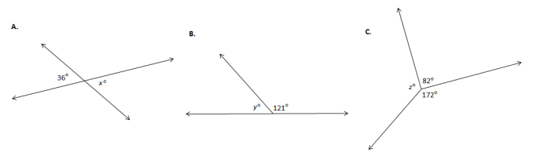

Guided Notes:
- Part a. is an example of ___________________. When two lines cross the opposite angles are ___________.
- Part b. is an example of a _________________. These angles are _____________ (which means that they add up to 180゜).
- Part c. is has three angles that form a circle so they add up to _______________.
- adjacent angles - are angles with a common side
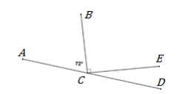
Which angles are adjacent here? ___________________________

1. Find the measure of angle HKI. 2. Find the measure of each angle.
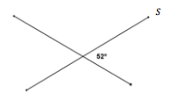
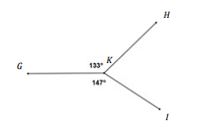

Independent Practice:
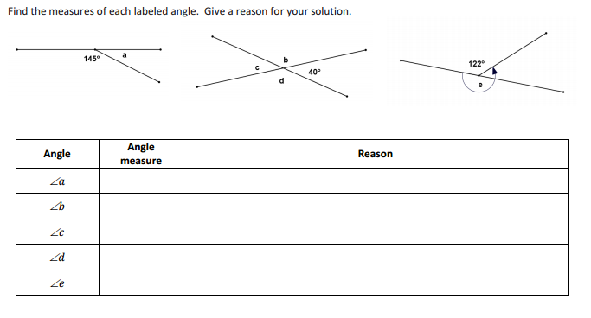

2. Find the value of x.
