Name:_______________________________ Date: _____________
Mr. Kaufman Geometry

Unit 1: Lesson 7 (Parallel Lines)

AIM: ___________________________________________________________________?

Do Now: Use what we learned yesterday to solve for x and y.
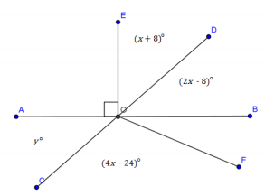

Guided Notes:
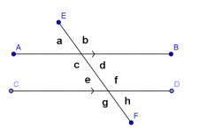
- a transversal is a line that cuts through two parallel lines
- corresponding angles are equal in measure

- alternate interior angles are equal in measure

- same-side interior angles are supplementary

Example Problems: For each problem explain how you found your answer.
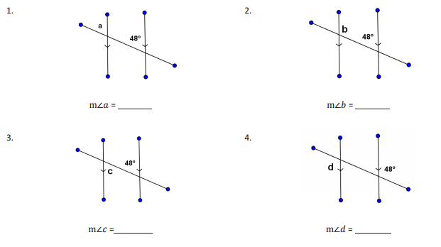

Independent Practice: Solve for each missing angle and explain how you arrived at your answer.

