EARTH science
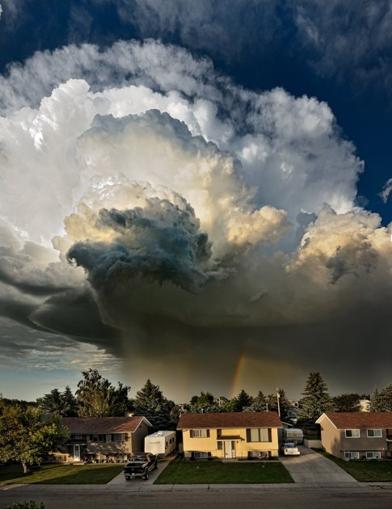
Dr. Wiprovnick’s Office Hours:
Period 8 Room 226
Monday, Wednesday and Friday

