OFFICERS
The AEC Electrical Scholarship And Educational Fund Corp.
36-36 33rd Street, Suite 402, Long Island City, NY 11106
Phone: 718.752.0800 Fax: 718.752.0805 www.aecnyc.com

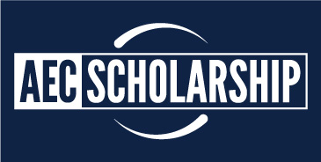

MEMORANDUM

TO: High School Guidance Counselors and College Advisors

SUBJECT: Applications for the 45th Annual Scholarship Awards
_________________________________________________________

The AEC Electrical Scholarship and Educational Fund Committee is requesting your assistance in circulating the attached “2016 AEC Scholarship Application” to Graduating Seniors who are interested in Electrical Engineering or a field related to the Electrical Construction Industry.

All applications MUST be received by the AEC Scholarship Fund Office on or before May 13th 2016.

The attached is the Application and 2016 Solicitation Letter that provides a brief history of the Scholarship Program. OR visit http://www.aecnyc.com/scholarship/ to download the 2016 Scholarship Application.

Please feel free to contact me if you have any questions.

Thank you for your support and assistance.

JEFFREY ELMER
EXECUTIVE DIRECTOR
ASSOCIATION OF ELECTRICAL CONTRACTORS SCHOLARSHIP FUND
36-36 33rd STREET, SUITE 402
LONG ISLAND CITY, N.Y. 11106
TEL (718) 752-0800
FAX (718) 752-0805
JELMER@AECNYC.COM

Carol Kleinberg
President

JOHN GRUJA
Vice President/Chairman

BARRY TEGER
Recording Secretary

ROBERT SEPE
Treasurer

Board of Directors

MANNY BARRAL
JOHN BROXMEYER
ANTHONY CAULO
GEORGE CECALA
ANDREW DRAZIC
JEFF HAUSLER
PARAG KAPADIA
CAROL LIFTON
JOHN PINTO
CHRIS ROTHOWSKI
PAT TOOLAN

General Counsel

LEONARD TAUBENBLATT

Advisor

JEFFREY ELMER

Founder

HERBERT TIPPERMAN
(1919-1995)

