$20
Show Your School Spirit!
Pre-Order Your WHSAD T-Shirt Now!

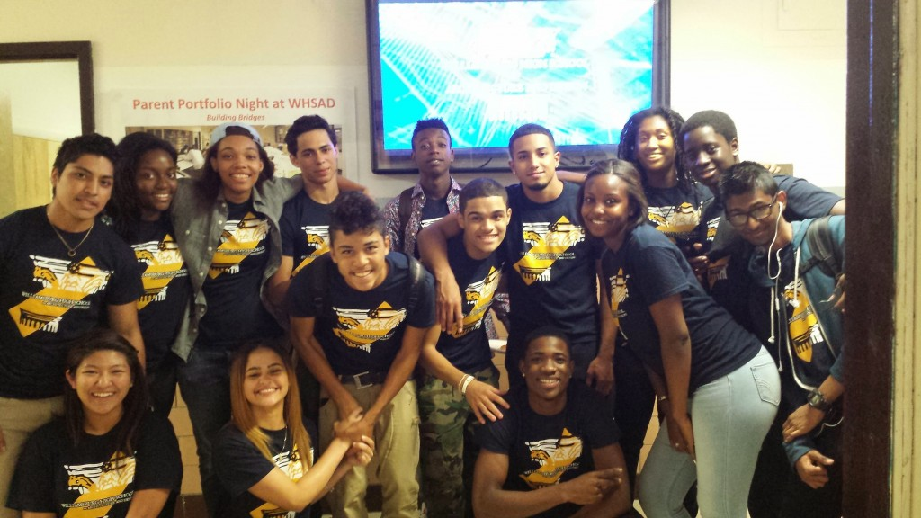

STUDENT’S NAME______________________________________________________________
PARENT’S NAME _______________________________________________________________
PHONE NUMBER _________________________________
ORDER SIZE/QTY SMALL/____ MEDIUM/____ LARGE/____
XLARGE/____ XXLARGE/____
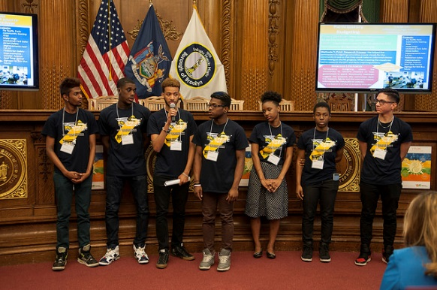
TOTAL # OF SHIRTS ____ TOTAL AMOUNT DUE __________ PAID ___________
SHOW YOUR SPIRIT –
WEAR YOUR WHSAD SHIRT ON FRIDAY’S!!!

ORDER TODAY OR DURING THE
MAY 3RD PARENT CONFERENCE.

Drop off payment (cash only) & order form to Ms. Terraferma in room 331.

