Dear Parents/Guardians,

Following Spring break we will be kicking off another round of AP and Regents Review. It is extremely important that your child attends as many review sessions as possible during the week and on weekends. Please check your child’s Regents Exam Invitation to determine which exam they are taking.

Mondays and Tuesdays from 2:45 pm – 3:45 pm – All teachers will be offering review and make-up sessions.

Wednesdays from 2:45 pm – 5:45 pm- Mr. Okrasinki (Room 216- Science) and Mr. Leverenz (Room 225- Math) will be available to help students with any science or math work.

Thursdays from 2:45 pm – 5:45 pm- Mr. Koestner (Room 202- ELA) and Ms. Weinstein (Room 205- Social Studies) will be available to help students with any English or social studies work.

Saturdays- Each Saturday teachers from all subject areas will be available from 9 am- 2 pm to prepare students for AP exams or Regents exams. If your child is taking multiple exams they can divide their time with different teachers. Even if your child’s teacher is not listed on the schedule the teacher filling in for them will be conducting the review session. It is extremely important that your child attends as many sessions as possible. Students taking the AP Spanish or LOTE Exam in Spanish will be invited directly by Ms. Soto to specific Saturday review sessions.

Subject | Date | Teacher | Room
AP Human Geo | 30-Apr | Ms. Connors | 209
Chemistry/ Science | Saturday | Ms. Ostashevsky | 510
Earth Science |  | Dr. Wiprovnick | 226
U.S. History/ Global |  | Ms. Weinstein | 205
Algebra 1 |  | Ms. Tan | 225
Subject | Date | Teacher | Room
Chemistry ONLY | 2-May | Ms. Ostashevsky | 510
 | Monday
Subject | Date | Teacher | Room
Earth Science | 7-May | Dr. Wiprovnick | 226
U.S. History | Saturday | Ms. Weinstein | 205
Global History |  | Ms. Como | 211
Geometry, Alg, Alg2 |  | Ms. Decker/ Ms. Tan | 213
Living Environment |  | Mr. Okrasinski | 216
Subject | Date | Teacher | Room
Global History | 14-May | Ms. Connors | 211
Chemistry | Saturday | Ms. Ostashevsky | 510
Earth Science |  | Dr. Wiprovnick | 226
U.S. History |  | Ms. Weinstein | 205
Geometry, Alg, Alg2 |  | Ms. Decker/ Ms. Tan/ Ms. Jimenez | 213
Living Environment |  | Mr. Okrasinski/ Mr. Giambrone | 216
Subject | Date | Teacher | Room
Global History | 21-May | Ms. Como | 211
Chemistry | Saturday | Ms. Ostashevsky | 510
U.S. History |  | Ms. Connors/ Ms. Weinstein | 205
Geometry, Alg, Alg2 |  | Ms. Decker/ Ms. Tan/ Ms. Jimenez | 213
Living Environment |  | Mr. Okrasinski | 216
Subject | Date | Teacher | Room
Global History | 28-May | Ms. Como | 211
Chemistry | Saturday | Ms. Ostashevsky | 510
Living Env./ Earth Science |  | Mr. Giambrone | 226
U.S. History |  | Ms. Weinstein | 205
Algebra |  | Ms. Tan | 225
Subject | Date | Teacher | Room
Global History | 4-Jun | Ms. Como | 211
Chemistry | Saturday | Ms. Ostashevsky | 510
Earth Science |  | Dr. Wiprovnick | 226
Geometry, Alg, Alg2 |  | Ms. Decker/ Ms. Tan | 213
Living Environment | June 4 | Mr. Okrasinski | 216
Subject | Date | Teacher | Room
Global History | 11-Jun | Ms. Como | 211
Chemistry | Saturday | Ms. Ostashevsky | 510
Earth Science | June 11 | Dr. Wiprovnick | 226
Geometry, Alg, Alg2 |  | Ms. Decker/ Ms. Tan/ Ms. Jimenez | 213
Living Environment |  | Mr. Okrasinski/ Mr. Giambrone | 216
Dr. Wiprovnick will offer lab make-up/tutoring for Earth Science on Wednesday and Thursday after school.
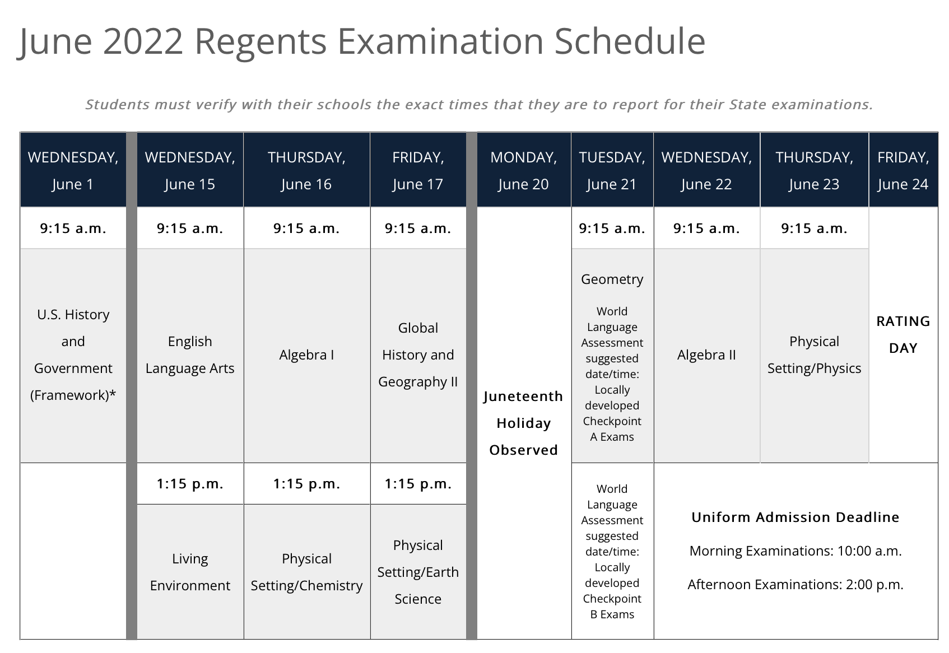
If you have any specific questions feel free to contact your child’s counselor or Assistant Principal.
Contact Information:
Ms. Chu, Parent Coordinator- 718-388-1260 Ext 2273, chu@whsad.org
Ms. Erneste, 9th and 11th Grade Counselor- 718-388-1260 Ext 2070, erneste@whsad.org
Ms. Small, All grades Instructional Support- 718-388-1260 Ext 2080, small@whsad.org
Ms. Terraferma, 10th and 12th Grade Counselor- 718-388-1260 Ext 3311, terraferma@whsad.org
Teacher Email- lastname@whsad.org / Example: Ms. Weinstein- weinstein@whsad.org
Ms. Basilio, AP of Guidance and Security- basilio@whsad.org
Ms. Bruno, AP of CTE, Math, Science, PE- bruno@whsad.org
Mr. D’Amato, AP of Social Studies, ELA, ESL, Spanish- damato@whsad.org

